Title of your paper (The title should be no longer than 90 characters)
First Name Last name^{1 *}, First Name Last name ¹, First Name Last name ², …
¹ Institution, City, Country. Email: email@address.com
² Institution, City, Country. Email: email@address.com

ABSTRACT
This template provides you with an example of the layout and style, which we wish you to adopt during the preparation of your extended abstract. Please, make an abstract as short as possible (5 to 8 lines). In order to ensure uniform style throughout the volume, all the abstracts have to be prepared strictly according to the instructions set below. The authors are recommended to prepare an extended abstract with 2 pages (never exceed 2 pages in length) and may follow the template described below.
Keywords: Keyword1; Keyword2; Keyword3 (Maximum 5 keywords)

1. Introduction
This template provides you with an example of the layout and style, which we wish you to adopt during the preparation of your paper.

2. Heading
2.1 Format
This template provides you with an example of the layout and style. No more than 2 pages.

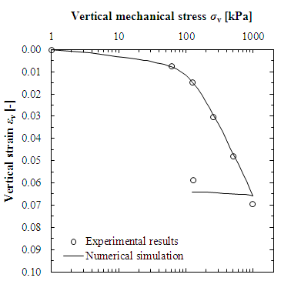
Fig. 1. Insert Figure Caption herein
This template provides you with an example of the layout and style. No more than 2 pages. This template provides you with an example of the layout and style. No more than 2 pages. This template provides you with an example of the layout and style. No more than 2 pages.

(1)
where, a = interface adhesion; b = friction angle at interface; and c = shear stiffness number.

Table 1. Table caption herein
A | 2 | 3 | 67
B | 1 | 4 | 55

This template provides you with an example of the layout and style. No more than 2 pages. This template provides you with an example of the layout and style. No more than 2 pages. This template provides you with an example of the layout and style. No more than 2 pages. This template provides you with an example of the layout and style. No more than 2 pages.

3. Conclusions
This template provides you with an example of the layout and style. No more than 2 pages. This template provides you with an example of the layout and style. No more than 2 pages. This template provides you with an example of the layout and style. No more than 2 pages.

Acknowledgements
This template provides you with an example of the layout and style. No more than 2 pages. This template provides you with an example of the layout and style. No more than 2 pages. This template provides you with an example of the layout and style. No more than 2 pages.

References
Hansbo, S. & Jendeby, L. (1998). “A follow-up of two different foundation principles”, Proceeding 4th International Conference on Case Histories in Geotechnical Engineering, March, St. Louis, Missouri, pp. 259-264.

